Kitchen Cabinets Design Specification

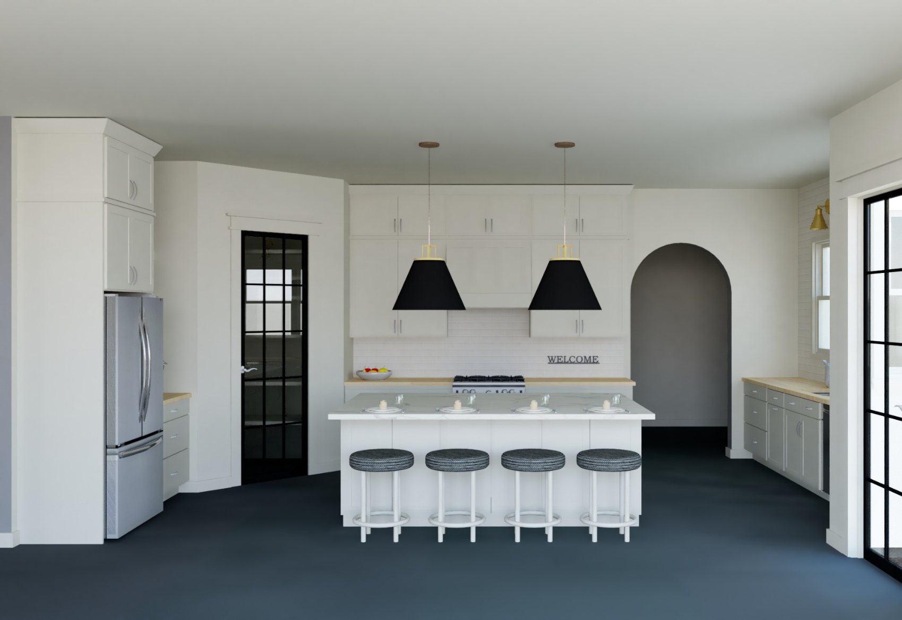

December 18, 2019

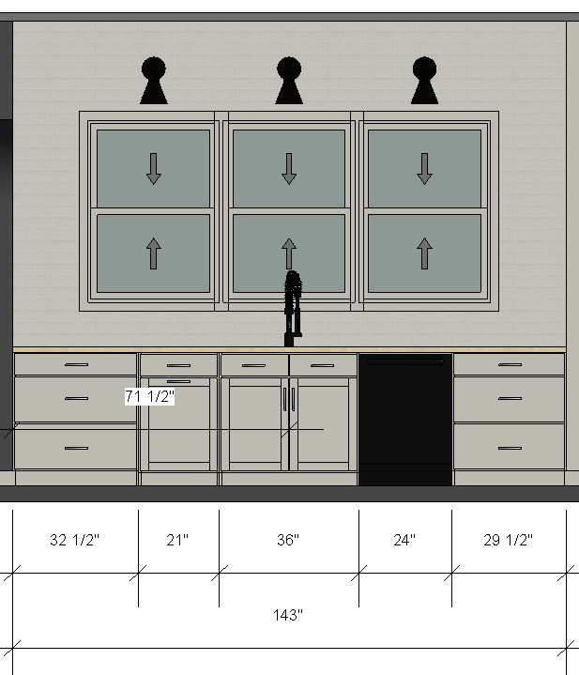**Sink Wall**

Cabinets

* Three-drawer cabinet – 32.5” W x 34.5” H x 24” D
* Pull-out garbage cabinet - 21” W x 34.5” H x 24” D
* Sink cabinet (centered under windows) – 36” W x 34.5” H x 24” D
* Three-drawer cabinet – 29.5” W x 34.5” H x 24” D

Electrical Needs

* Dishwasher, garbage disposal outlet & switch
* Outlets above countertops
* Lights centered above each window, and switch

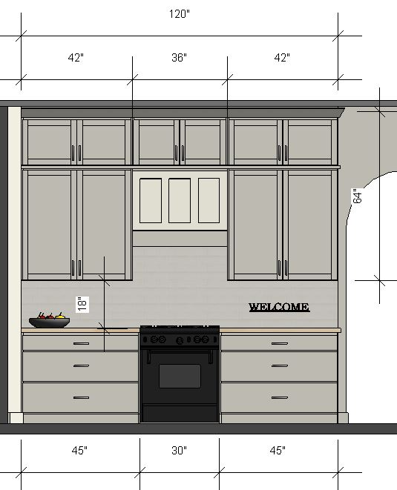**Stove Wall**

Cabinets

* Two upper cabinets with two fixed shelves and two adjustable shelves each –

42” W x 64” H x 12” D

* One upper cabinet above range hood – 36” W x 22” H x 12” D
* Range hood – 36” W x 20.25” D
* Two lower cabinets with three drawers each – 45” W x 34.5” H x 24” D

Electrical Needs

* Vent hood outlet – 88” up from floor, 63” from wall on left
* Outlets above countertops
* Under cabinet lights & switch

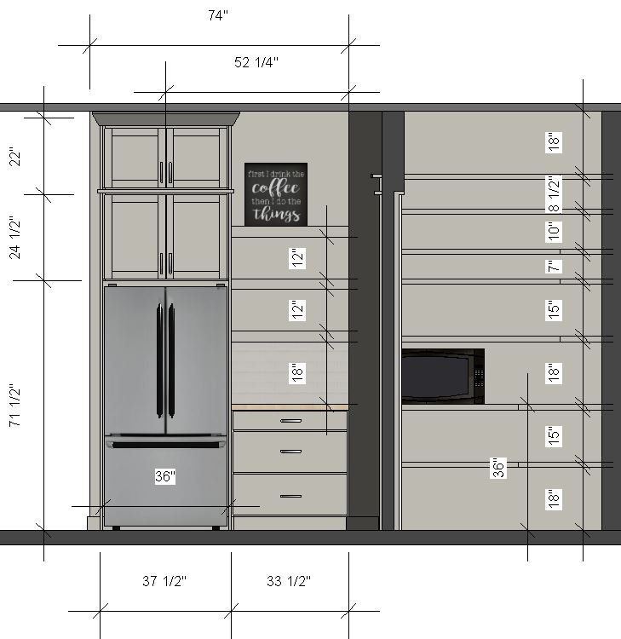**Refrigerator Wall Pantry Shelves**

**Refrigerator opening requirement:**

**36” W x 71 ½” H**

Cabinets

* Cabinet above refrigerator with pull-out shelf – 36” W x 24.5” H x 24” D
* Cabinet above refrigerator pull-out – 36” W x 22” H x 24” D
* Three-drawer cabinet – 33.5” W x 34.5” H x 24” D
* Three open shelves – 33.5” W x 3” H x 12” D

Electrical Needs

* Refrigerator outlet & coffee pot outlet
* Three or four outlets in pantry (at “above countertop” level)
* Under cabinet light & switch in coffee bar area
* Light & switch in pantry

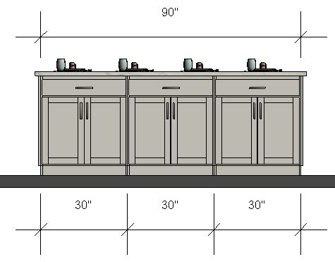**Island**

**Kitchen Side**

**Seating Side**

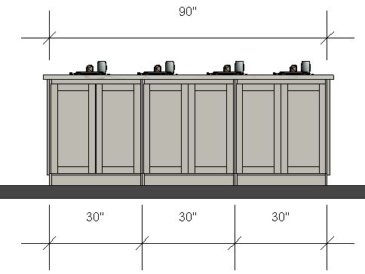

Cabinets

* One cabinet with one drawer and cookie sheet storage – 30” W x 34.5” H x 24” D
* Two cabinets with one drawer and two pull-out shelves – 30” W x 34.5” H x 24” D
* Three cabinets with three pull-out shelves – 30” W x 34.5” W x 24” D

15” overhang of countertop on seating side

Electrical Needs

* Outlets on both sides of island
* Two pendant lights centered above island, and switch

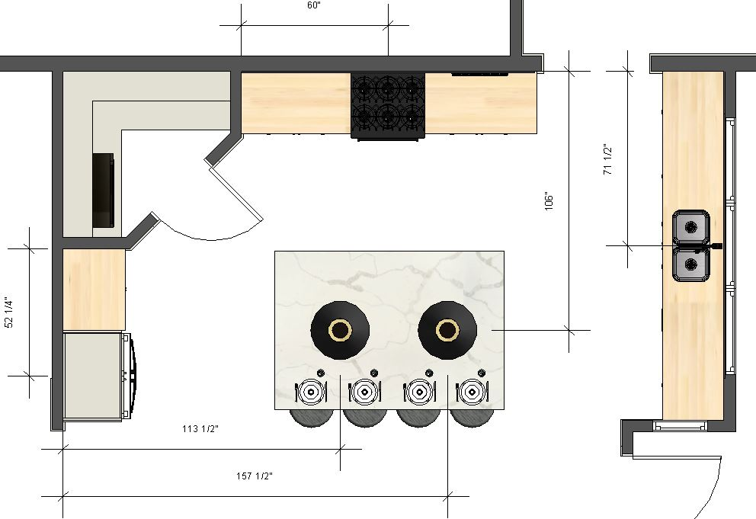**Kitchen Layout – Electrical Needs**

**Kitchen electrical needs summary**

* Garbage disposal outlet & switch
* Dishwasher
* Vent hood outlet – 88” up from floor, 63” from wall on left
* Island – outlets on both sides
* Refrigerator outlet
* Outlets above all countertops
* Three or four outlets in walk-in pantry at countertop level
* Lights & switches in ceiling, pantry, above island, and over each sink window
* Under cabinet lights on both sides of stove and coffee bar area with switches

**Kitchen Layout – Cabinet Needs**

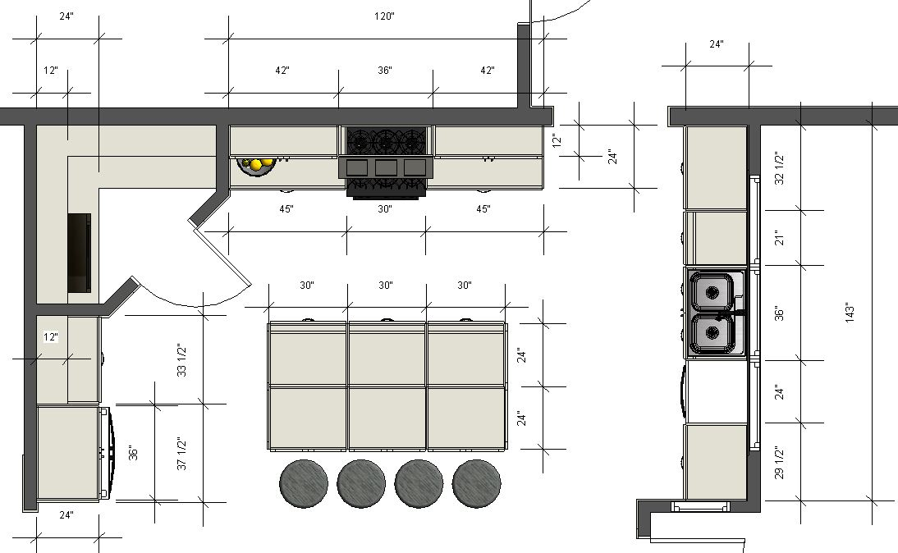

**Kitchen cabinet summary**

* Nineteen (19) cabinets
* Twenty-nine (29) doors
* Twenty-one (21) drawer fronts
* Nineteen (19) drawer boxes
* Thirteen (13) pull-out shelves (lower cabinets)
* Two (2) ¾” side panels for refrigerator cabinets that go to floor
* Two (2) decorative end panels for island
* One (1) 36” shaker vent hood cover
* One (1) pull-out garbage next to sink
* One (1) pull-out over refrigerator
* One (1) cookie sheet divider section in island
* One (1) spice drawer insert for drawer on stove wall (optional)
* One (1) 24” deep counter for microwave in pantry
* One (1) 24” deep pantry shelf below counter
* Five (5) 12” deep pantry shelves
* Crown molding at 10’ around upper cabinets
* Trim piece at 8’ level around upper cabinets to hide cabinet seams
* Soft-close door hinges
* Soft-close drawer slides, 100 lb. capacity per pair

**Laundry Room**

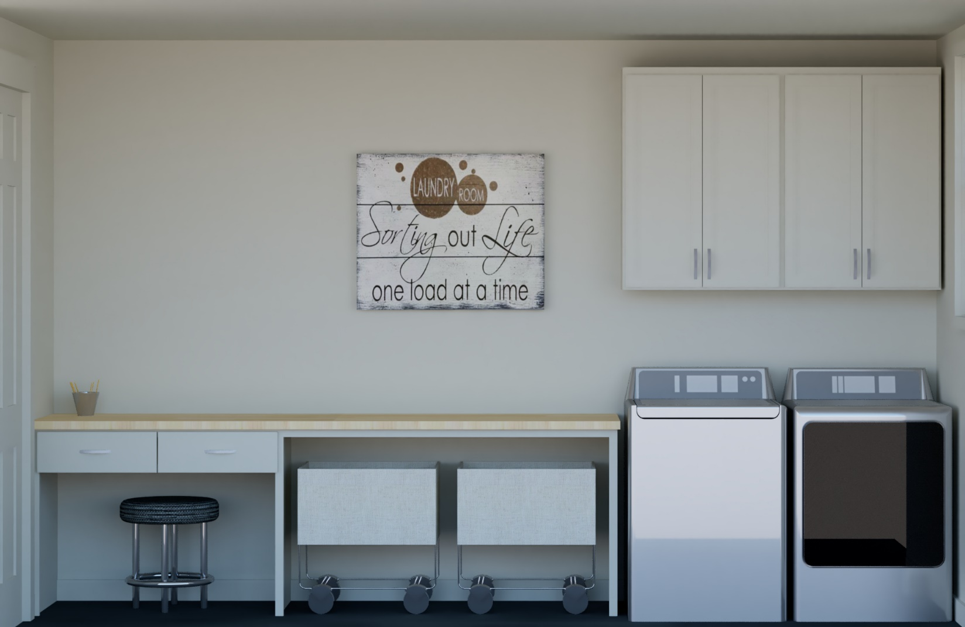

**Laundry Room - Cabinets**

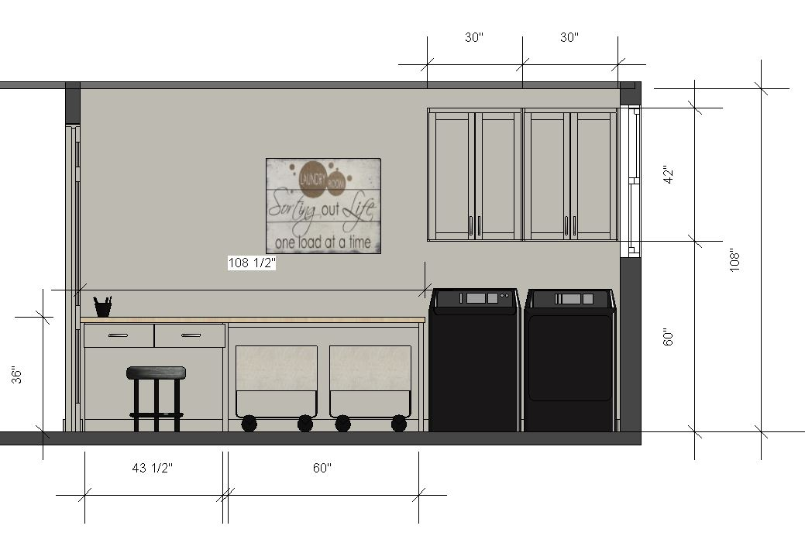

Cabinets

* Two cabinets over washer and dryer – 30” W x 42” H x 12” D each
* Two drawers in desk area – 20.5” W x 4.5” H x 22” D each

Supports for butcher block countertop, with opening for desk area and laundry sorters

**Laundry Room – Layout & Countertop**

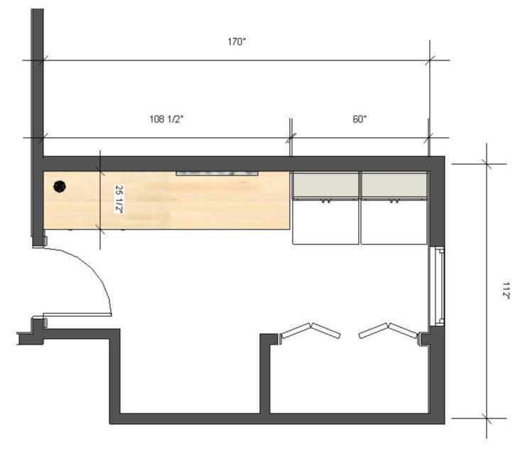

**Washer**

**Dryer**